Exercise 1

Task 1
Create an HTML page with the following characteristics:
1) Page title: "My first page"
2) Page description: "This is my first HTML page"
3) Add keywords: HTML, page, first attempt

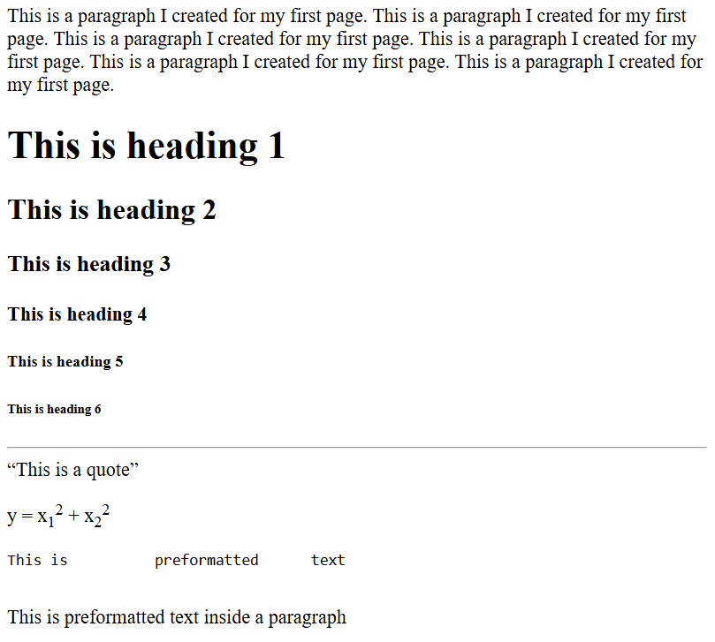

Task 2
1) Create a folder with your faculty number. Create an HTML file named index.html.
2) Set the page title to "Confectionery Aida - Varna", page description: "Official website of confectionery 'Aida' - Varna", keywords: confectionery, cakes, pastries, ice cream; author: Your name.
3) Create content with the following layout.
4) Organize the content in container tags <div> at your discretion.

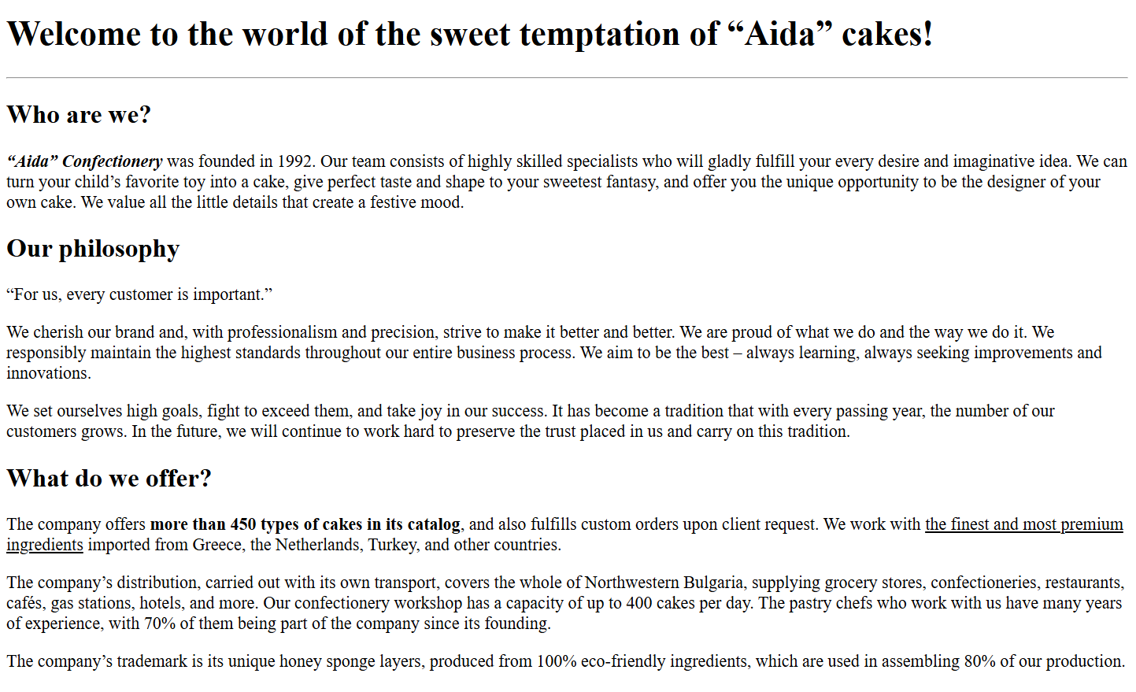
Text:

Welcome to the world of the sweet temptation of “Aida” cakes!
Who are we?
“Aida” Confectionery was founded in 1992. Our team consists of highly skilled specialists who will gladly fulfill your every desire and imaginative idea. We can turn your child’s favorite toy into a cake, give perfect taste and shape to your sweetest fantasy, and offer you the unique opportunity to be the designer of your own cake. We value all the little details that create a festive mood.
Our philosophy
For us, every customer is important.
We cherish our brand and, with professionalism and precision, strive to make it better and better. We are proud of what we do and the way we do it. We responsibly maintain the highest standards throughout our entire business process. We aim to be the best – always learning, always seeking improvements and innovations.
We set ourselves high goals, fight to exceed them, and take joy in our success. It has become a tradition that with every passing year, the number of our customers grows. In the future, we will continue to work hard to preserve the trust placed in us and carry on this tradition.
What do we offer?
The company offers more than 450 types of cakes in its catalog, and also fulfills custom orders upon client request. We work with the finest and most premium ingredients imported from Greece, the Netherlands, Turkey, and other countries.
The company’s distribution, carried out with its own transport, covers the whole of Northwestern Bulgaria, supplying grocery stores, confectioneries, restaurants, cafés, gas stations, hotels, and more. Our confectionery workshop has a capacity of up to 400 cakes per day. The pastry chefs who work with us have many years of experience, with 70% of them being part of the company since its founding.
The company’s trademark is its unique honey sponge layers, produced from 100% eco-friendly ingredients, which are used in assembling 80% of our production.

Task 3
In a new HTML page, create the following lists:
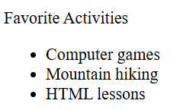
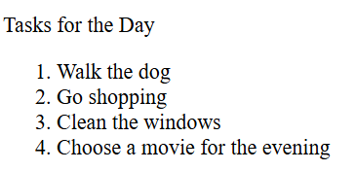
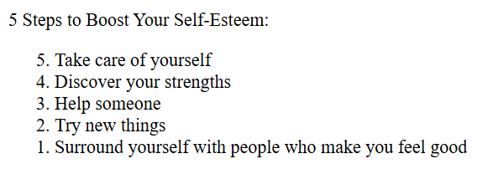
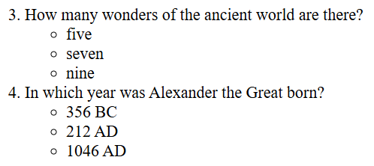
Texts:
Favorite Activities
Computer games
Mountain hiking
HTML lessons

Tasks for the Day
Walk the dog
Go shopping
Clean the windows
Choose a movie for the evening

5 Steps to Boost Your Self-Esteem:
Take care of yourself
Discover your strengths
Help someone
Try new things
Surround yourself with people who make you feel good

>How many wonders of the ancient world are there?
five
seven
Nine
In which year was Alexander the Great born?
356 BC
212 AD
1046 AD

Task 4
Create the following html page. Describe the content with the necessary tags.

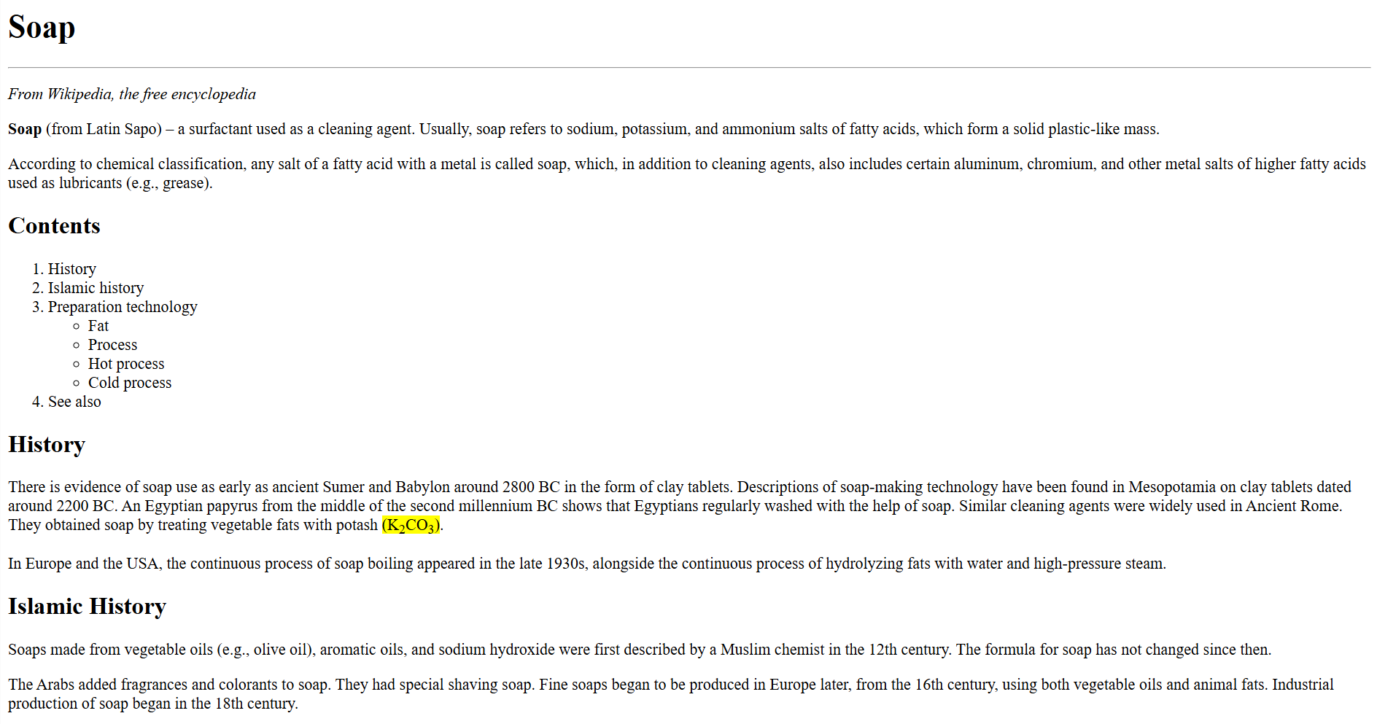
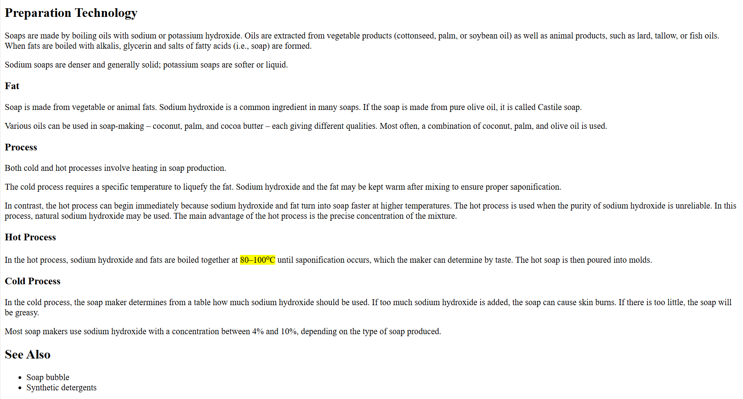

Text

Soap
From Wikipedia, the free encyclopedia

Soap (from Latin Sapo) – a surfactant used as a cleaning agent. Usually, soap refers to sodium, potassium, and ammonium salts of fatty acids, which form a solid plastic-like mass.
According to chemical classification, any salt of a fatty acid with a metal is called soap, which, in addition to cleaning agents, also includes certain aluminum, chromium, and other metal salts of higher fatty acids used as lubricants (e.g., grease).

Contents
History
Islamic history
Preparation technology
Fat
Process
Hot process
Cold process
See also

History

There is evidence of soap use as early as ancient Sumer and Babylon around 2800 BC in the form of clay tablets. Descriptions of soap-making technology have been found in Mesopotamia on clay tablets dated around 2200 BC. An Egyptian papyrus from the middle of the second millennium BC shows that Egyptians regularly washed with the help of soap. Similar cleaning agents were widely used in Ancient Rome. They obtained soap by treating vegetable fats with potash (K2CO3).

In Europe and the USA, the continuous process of soap boiling appeared in the late 1930s, alongside the continuous process of hydrolyzing fats with water and high-pressure steam.

Islamic History

Soaps made from vegetable oils (e.g., olive oil), aromatic oils, and sodium hydroxide were first described by a Muslim chemist in the 12th century. The formula for soap has not changed since then.

The Arabs added fragrances and colorants to soap. They had special shaving soap.
Fine soaps began to be produced in Europe later, from the 16th century, using both vegetable oils and animal fats. Industrial production of soap began in the 18th century.

Preparation Technology

Soaps are made by boiling oils with sodium or potassium hydroxide. Oils are extracted from vegetable products (cottonseed, palm, or soybean oil) as well as animal products, such as lard, tallow, or fish oils. When fats are boiled with alkalis, glycerin and salts of fatty acids (i.e., soap) are formed.

Sodium soaps are denser and generally solid; potassium soaps are softer or liquid.

Fat

Soap is made from vegetable or animal fats. Sodium hydroxide is a common ingredient in many soaps. If the soap is made from pure olive oil, it is called Castile soap.

Various oils can be used in soap-making – coconut, palm, and cocoa butter – each giving different qualities. Most often, a combination of coconut, palm, and olive oil is used.

Process

Both cold and hot processes involve heating in soap production.

The cold process requires a specific temperature to liquefy the fat. Sodium hydroxide and the fat may be kept warm after mixing to ensure proper saponification.

In contrast, the hot process can begin immediately because sodium hydroxide and fat turn into soap faster at higher temperatures. The hot process is used when the purity of sodium hydroxide is unreliable. In this process, natural sodium hydroxide may be used. The main advantage of the hot process is the precise concentration of the mixture.

Hot Process

In the hot process, sodium hydroxide and fats are boiled together at 80–100 oC until saponification occurs, which the maker can determine by taste. The hot soap is then poured into molds.

Cold Process

In the cold process, the soap maker determines from a table how much sodium hydroxide should be used. If too much sodium hydroxide is added, the soap can cause skin burns. If there is too little, the soap will be greasy.

Most soap makers use sodium hydroxide with a concentration between 4% and 10%, depending on the type of soap produced.

See Also

Soap bubble
Synthetic detergents

